A000-US-Ohio-Pipe-Hopewell-Platform Curved-600 CE

# Hopewell platform pipe of Ohio pipestone, from Adams County, Ohio. Length: 3 ¾ in.; width: 1 ¾ in.; heigth: 2 in.

Estimate $700.00.

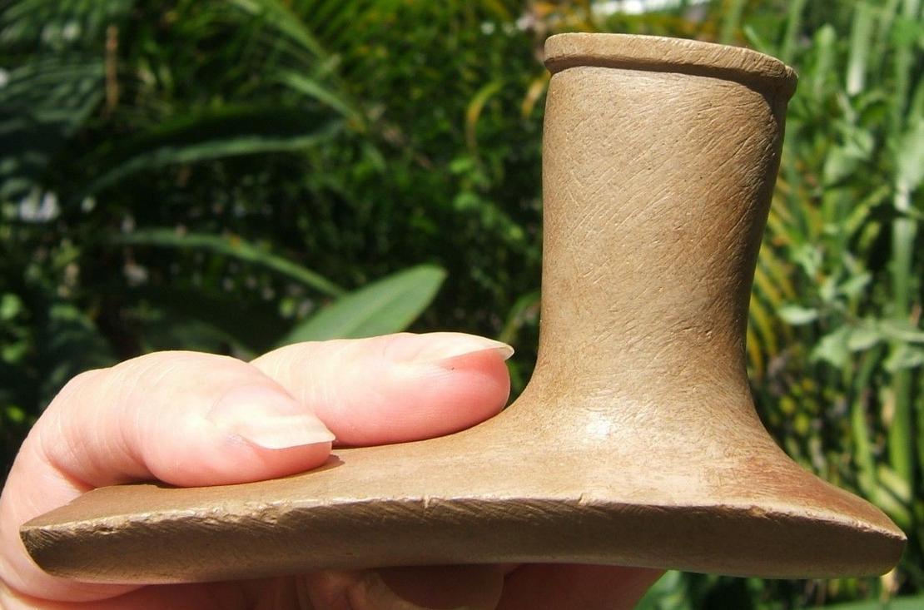

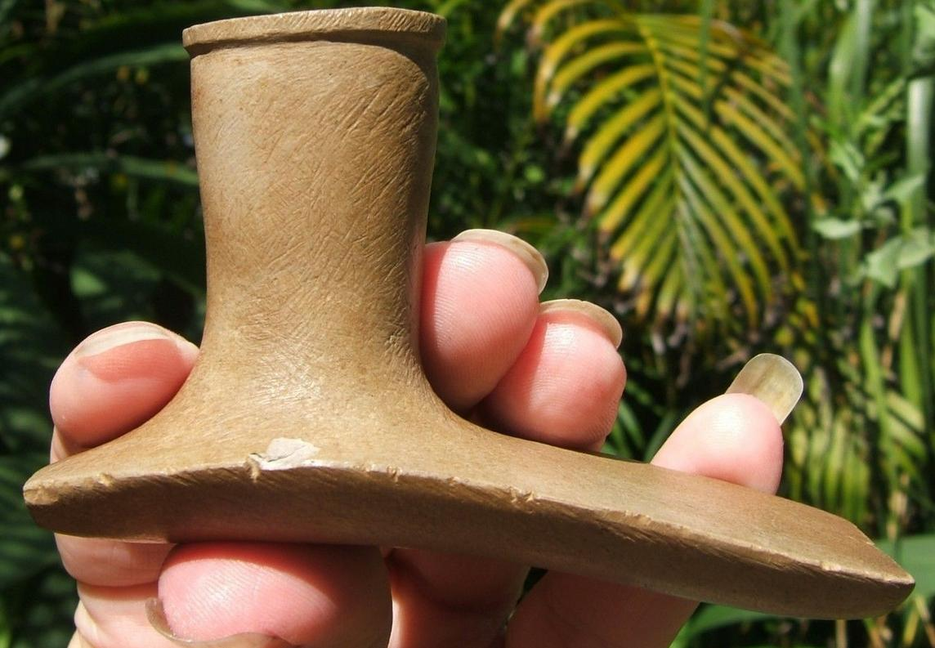

|  |  |
| --- | --- |
| ORDER DATEApr 11, 2016 | ORDER TOTAL  US $425.00  Free shipping  **Order 3 3/4" Museum Quality Hopewell Platform Pipe** [Leave feedback - ORDER DATE Apr 11, 2016](http://feedback.ebay.com/ws/eBayISAPI.dll?LeaveFeedbackShow&useridto=lynnscollectibles&transactID=1506477204001&item=111947891960&_trksid=p2057872.m2749.l2665)[View order details](http://payments.ebay.com/ws/eBayISAPI.dll?ViewPaymentStatus&transId=1506477204001&itemid=111947891960&_trksid=p2057872.m2749.l2673) - ORDER DATE Apr 11, 2016  [More actions - ORDER DATE Apr 11, 2016](http://www.ebay.com/myb/PurchaseHistory) |

1 item sold by [lynnscollectibles](http://www.ebay.com/usr/lynnscollectibles?_trksid=p2057872.m2749.l2754)

|  |  |  |
| --- | --- | --- |
| [3 3/4" Museum Quality Hopewell Platform Pipe](http://www.ebay.com/itm/111947891960?_trksid=p2057872.m2749.l2649&ssPageName=STRK%3AMEBIDX%3AIT)  ( 111947891960 )  Delivered on Thu, Apr 14  Tracking number: [**Tracking number**9505514162116103228013](javascript:;)  [Add note](javascript:;) | ITEM PRICE:  US $425.00 |  |